# NETWORKING&SYSTEM ADMINISTRATION LAB

**Name: Silvia THOMAS**

**Roll No: 38 Batch: MCA B Date: 23-5-22**

**Experiment No.: 24**

**Aim**

Installation of Docker

# Procedure

**Step1:** Open the terminal on Ubuntu.

**Step2:**  Remove any [Docker files](https://www.simplilearn.com/tutorials/docker-tutorial/what-is-dockerfile) that are running in the system, using the following command:

**syntax**

**$ sudo apt-get remove docker docker-engine docker.io**

**output**

# 

After entering the above command, you will need to enter the password of the root and press enter.

**Step3:** Check if the system is up-to-date using the following command:

syntax

$ sudo apt-get update

**output**

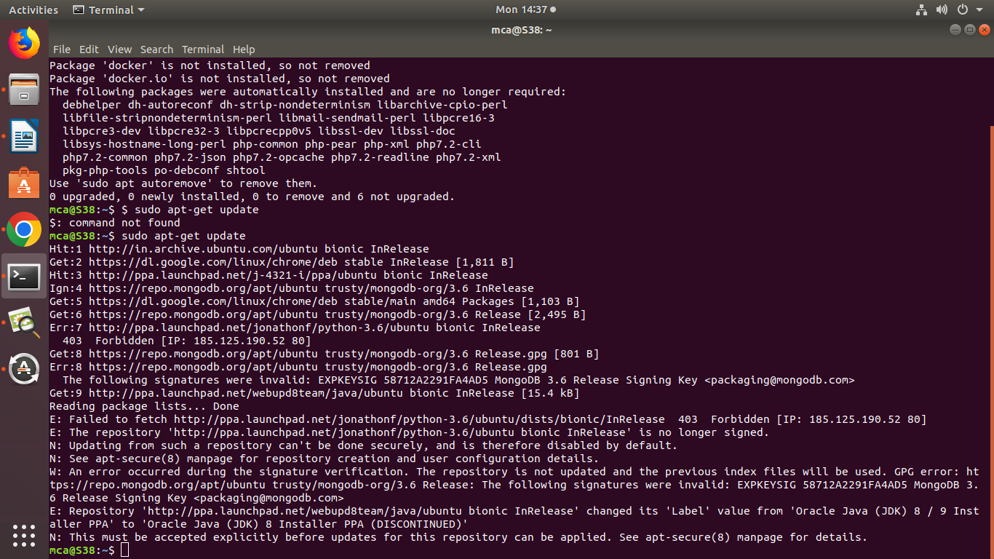

**step4:**Install Docker using the following command:

syntax

**$ sudo apt install docker.io**

output

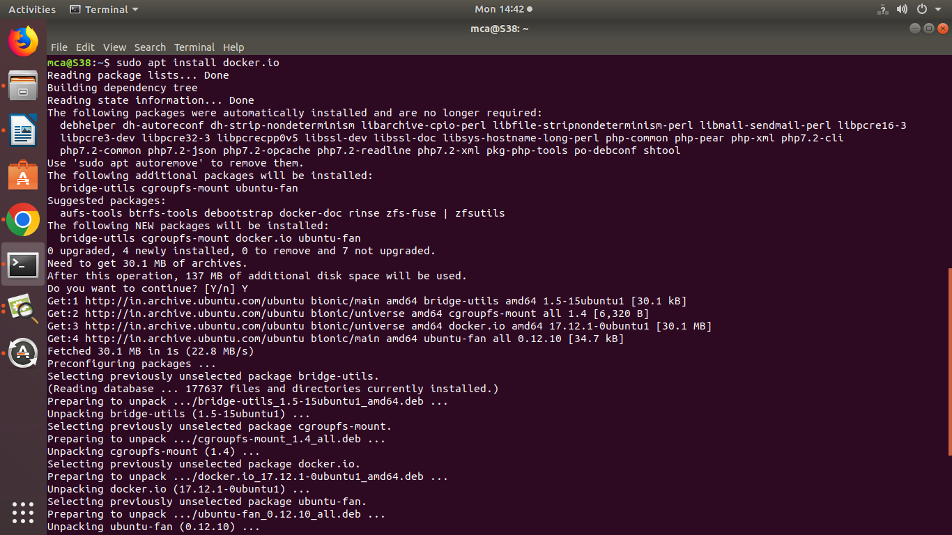

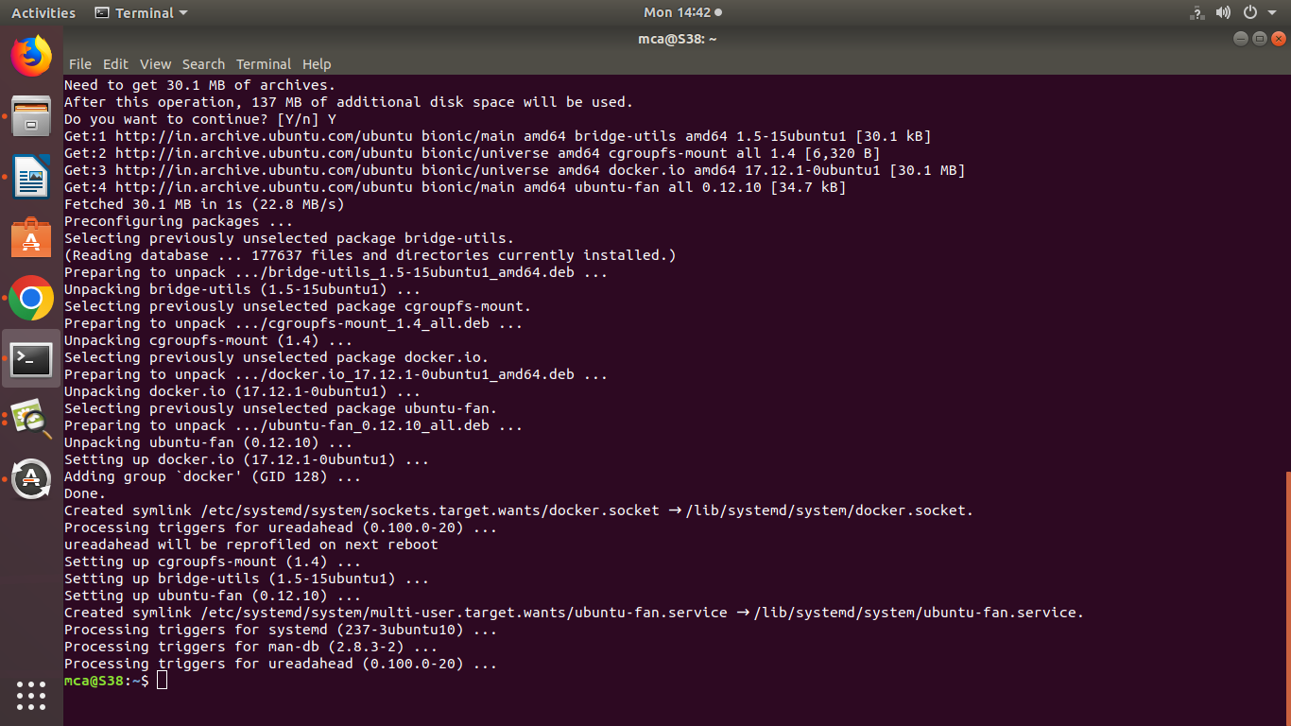

**step5:**Install all the dependency packages using the following command:

**syntax**

**$ sudo snap install docker**

**output**

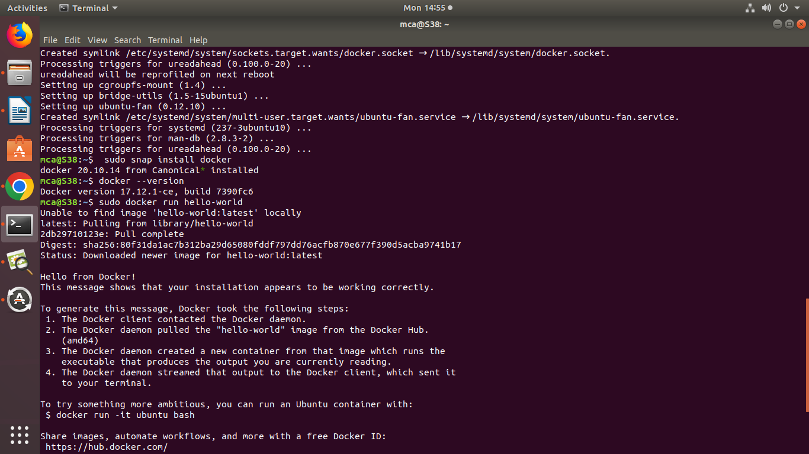

**Step 6:**Before testing Docker, check the version installed using the following command:

**syntax**

**$ docker –version**

**output**



**step7:**Pull an image from the Docker hub using the following command:

**syntax**

**$ sudo docker run hello-world**

**output**

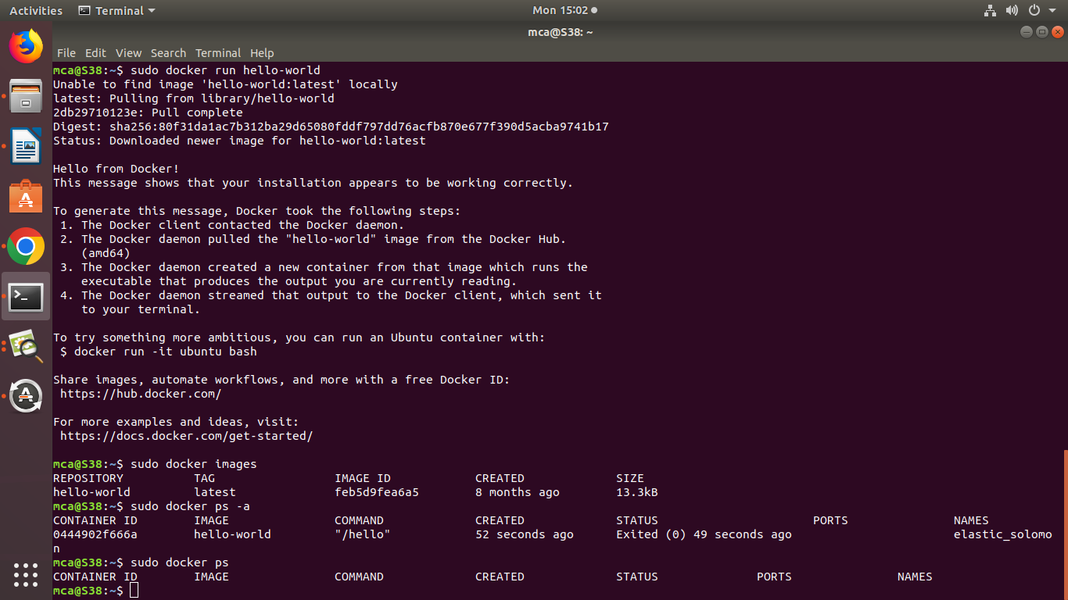

**step8:**Check if the docker image has been pulled and is present in your system using the following command:

**syntax**

**$ sudo docker images**

**output**

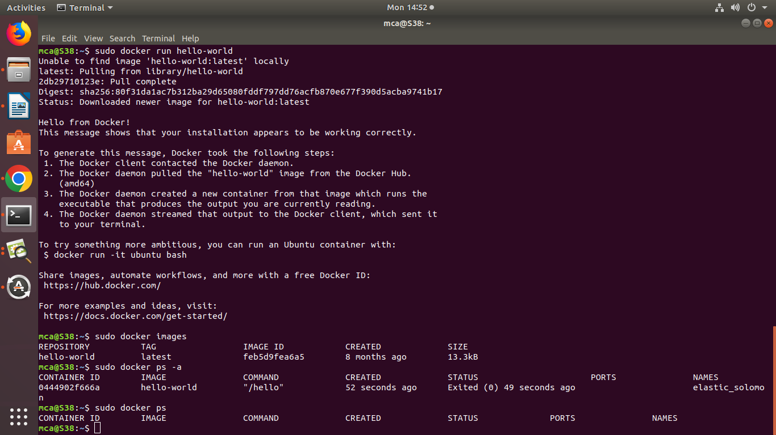

**step9:**To display all the containers pulled, use the following command:

**syntax**

**$ sudo docker ps -a**



**step 10:**To check for containers in a running state, use the following command:

**syntax**

**$ sudo docker ps**

**output**



**You’ve just successfully installed Docker on Ubuntu!**